**Process** **:**  Calibration of the camera lens distortion

# Test Target Grid : Edmund Optics - Chrome on Glass, 3 Frequency Grid Distortion Target

**Grid Specifications:** Dot Diameter - 1mm ±0.0025mm

Dot Center to Center Spacing - 1mm ±0.0025mm

# LabVIEW Version : LabVIEW 2015 (32 bit)

**Calibration Method:** NI Vision and Motion - Vision Express-Distortion Grid Calibration

**Step by Step Calibration**

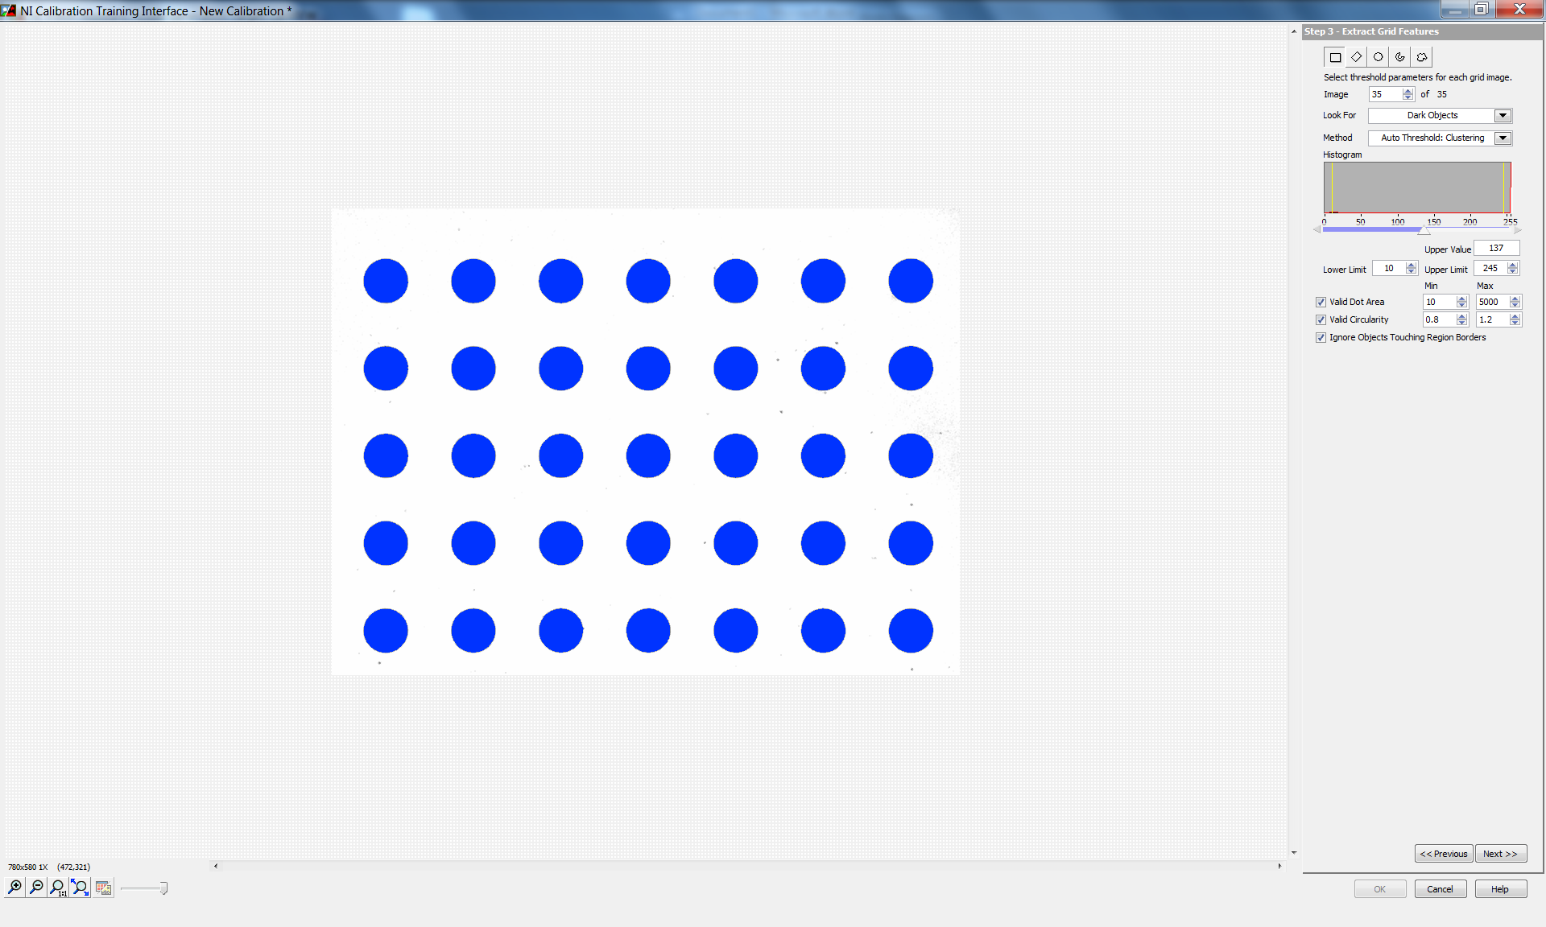

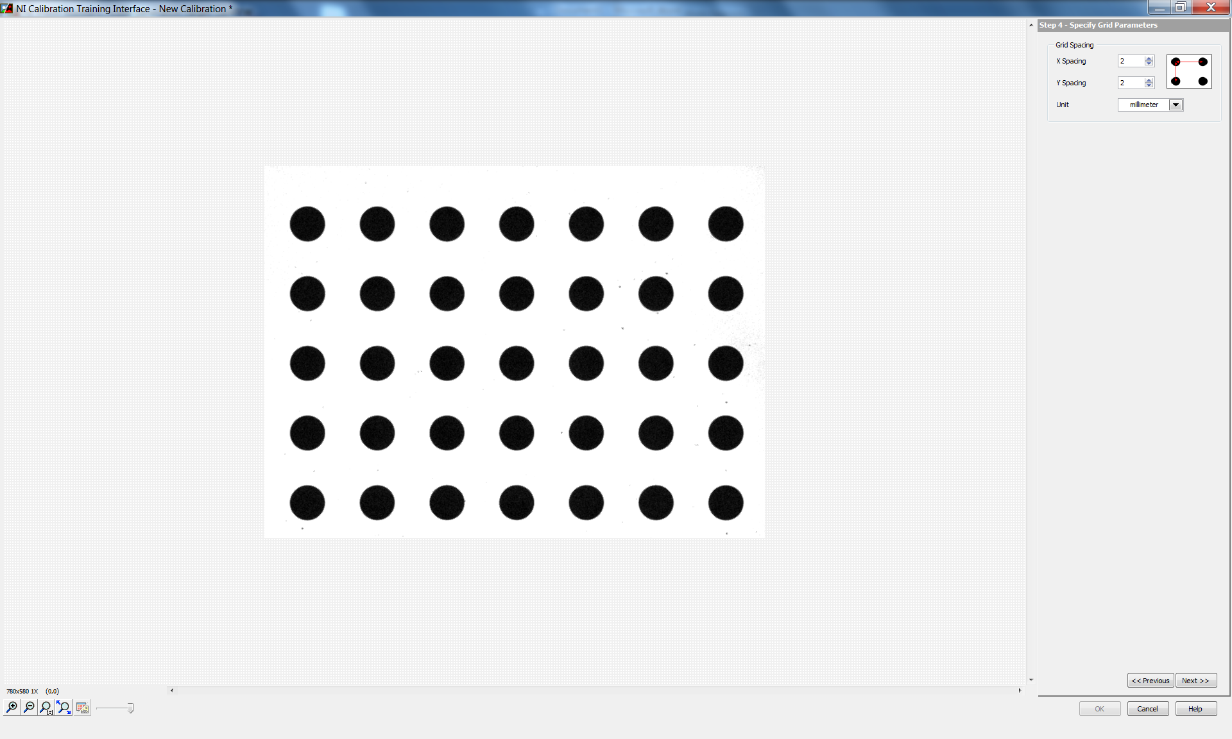

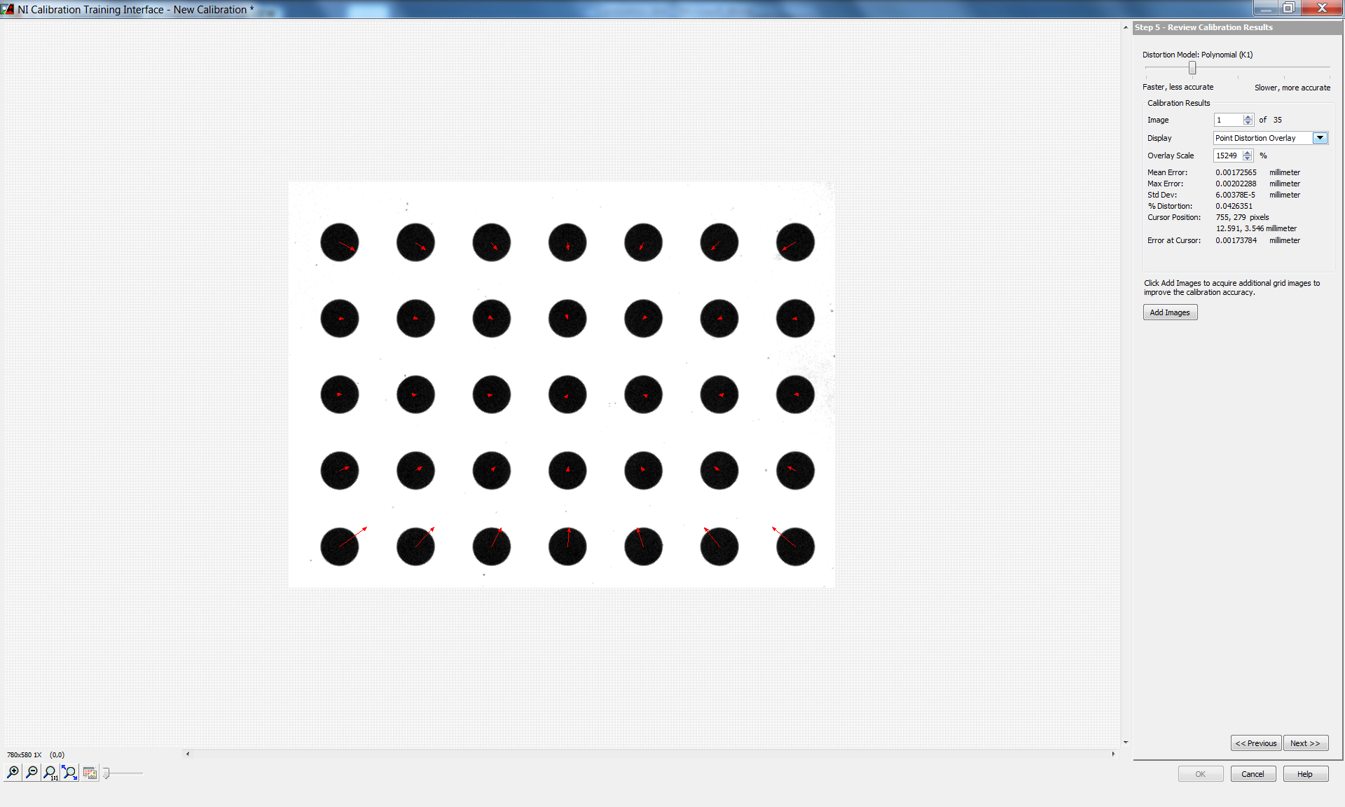

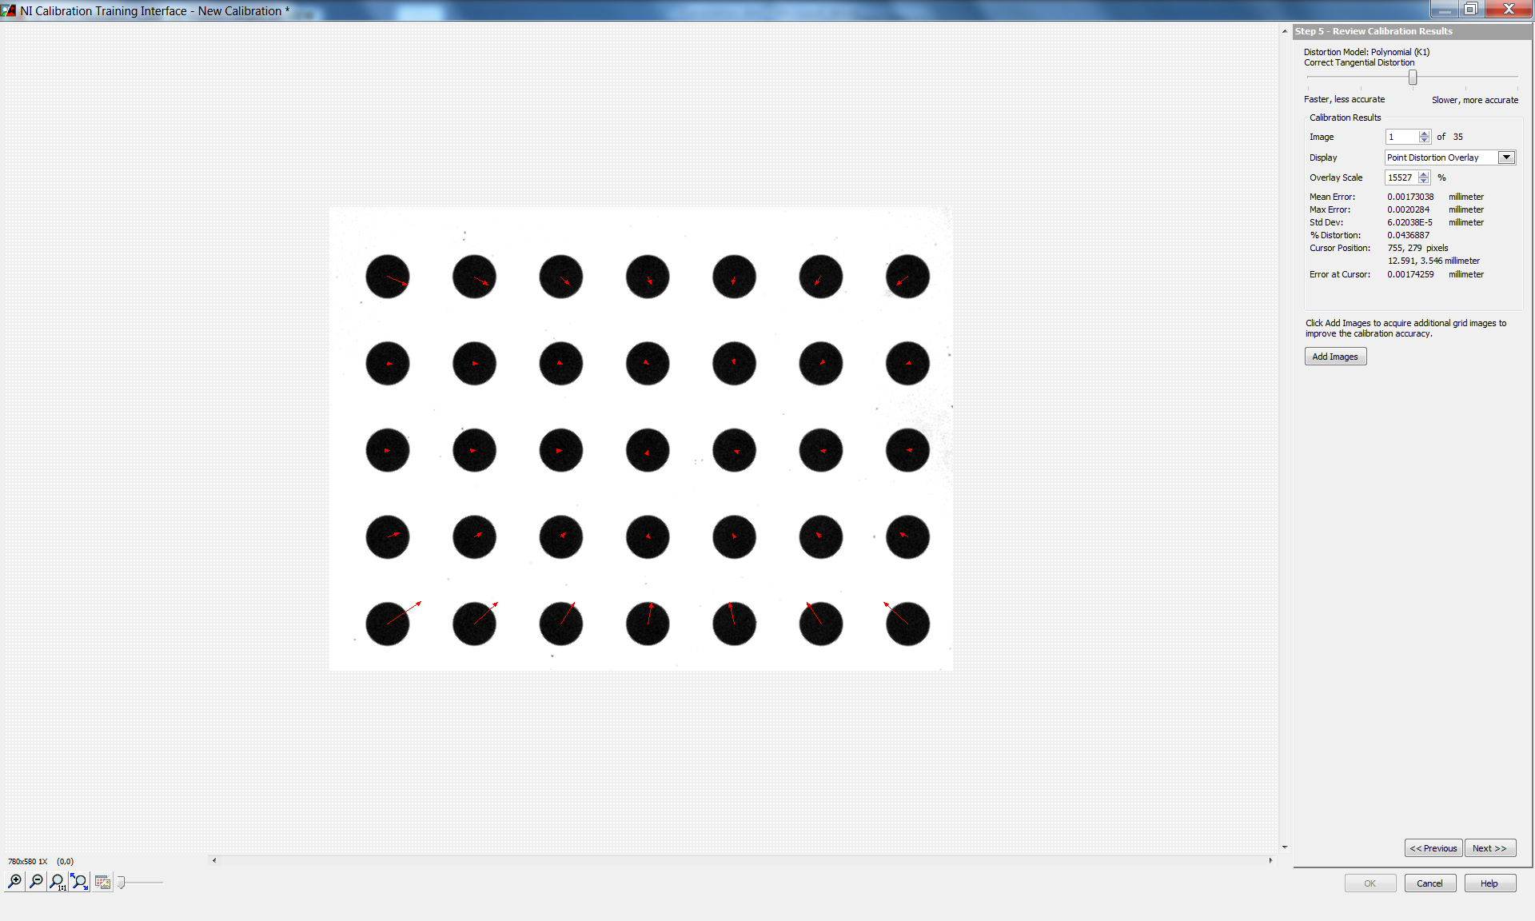

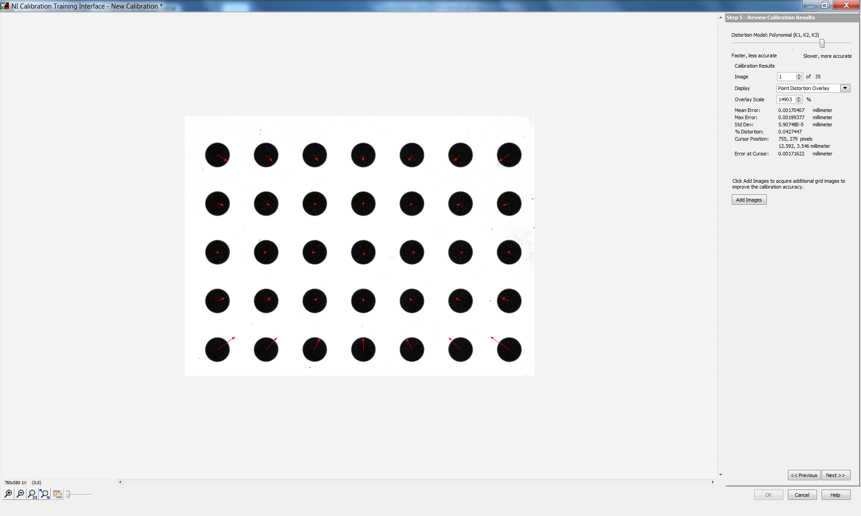

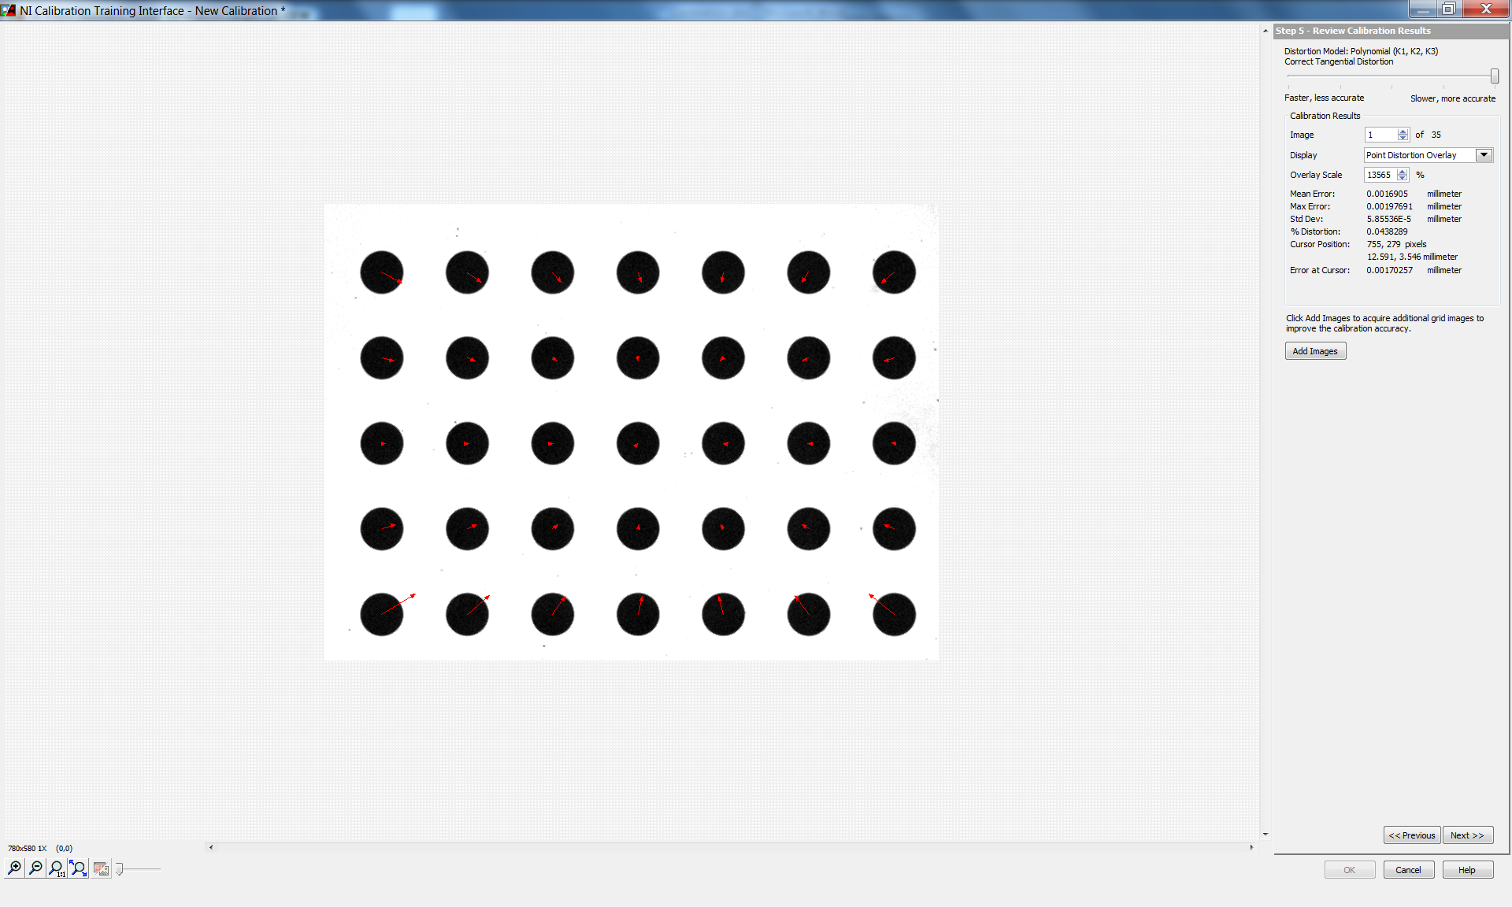

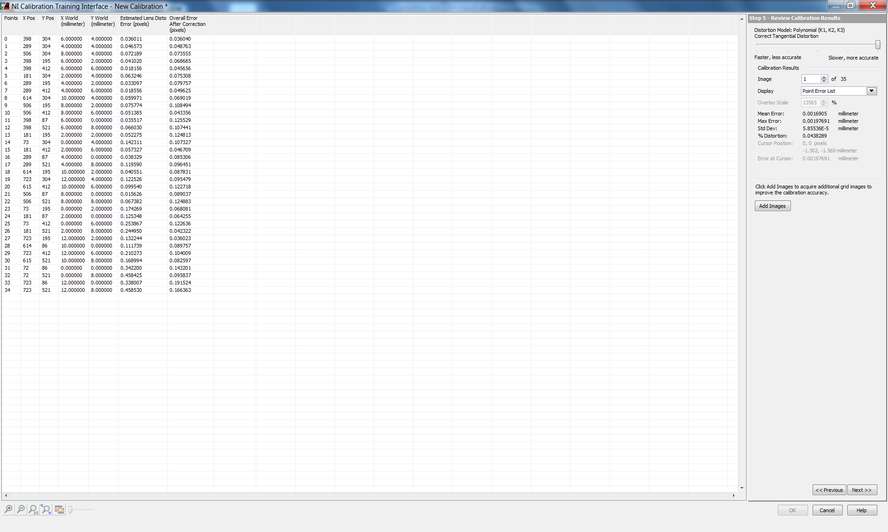

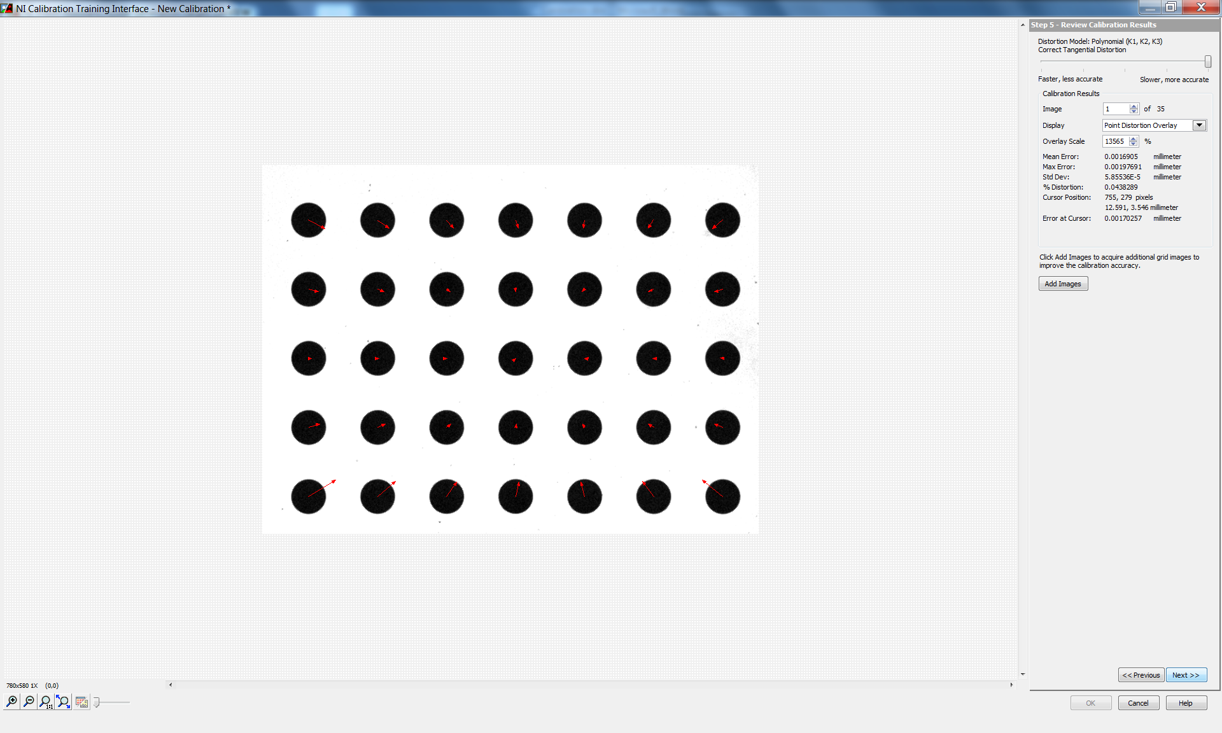

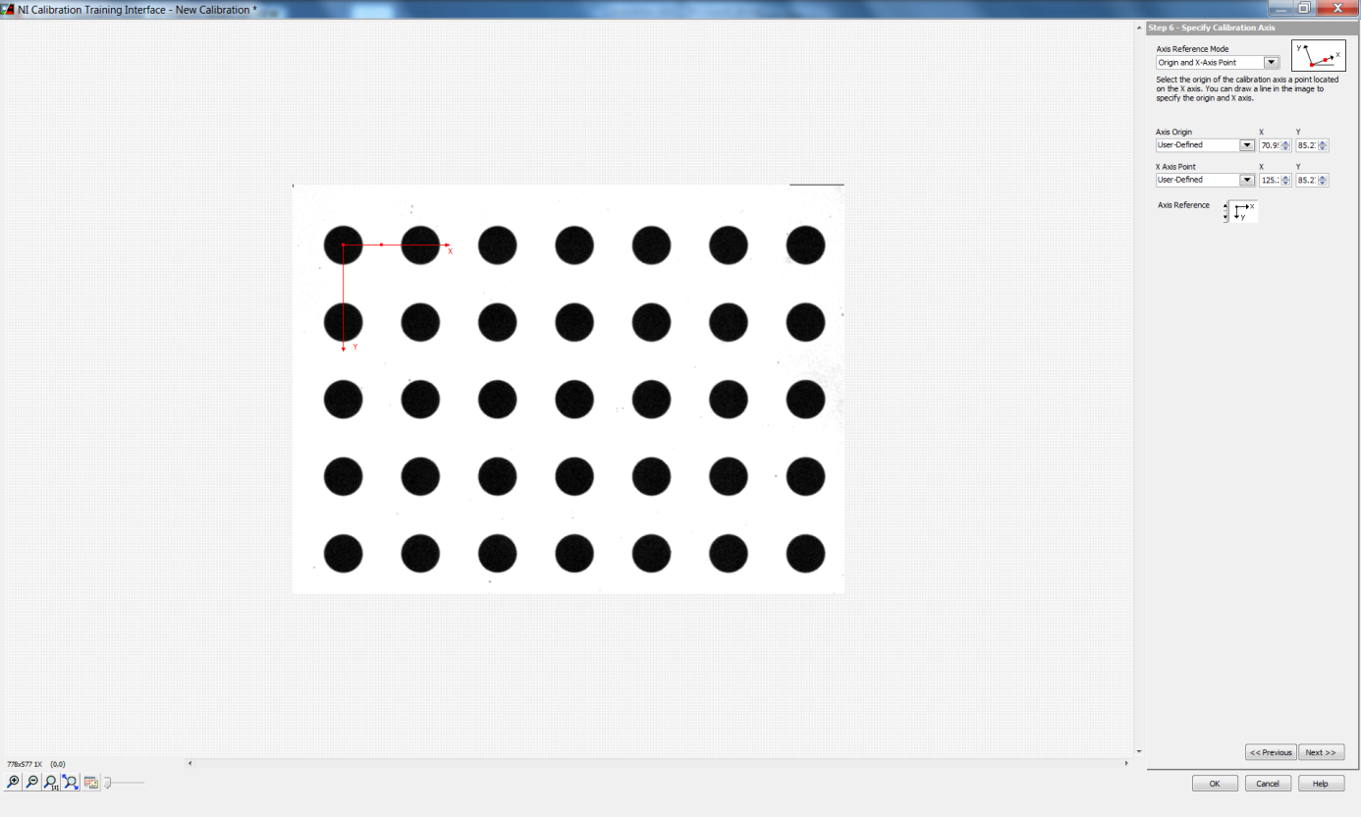

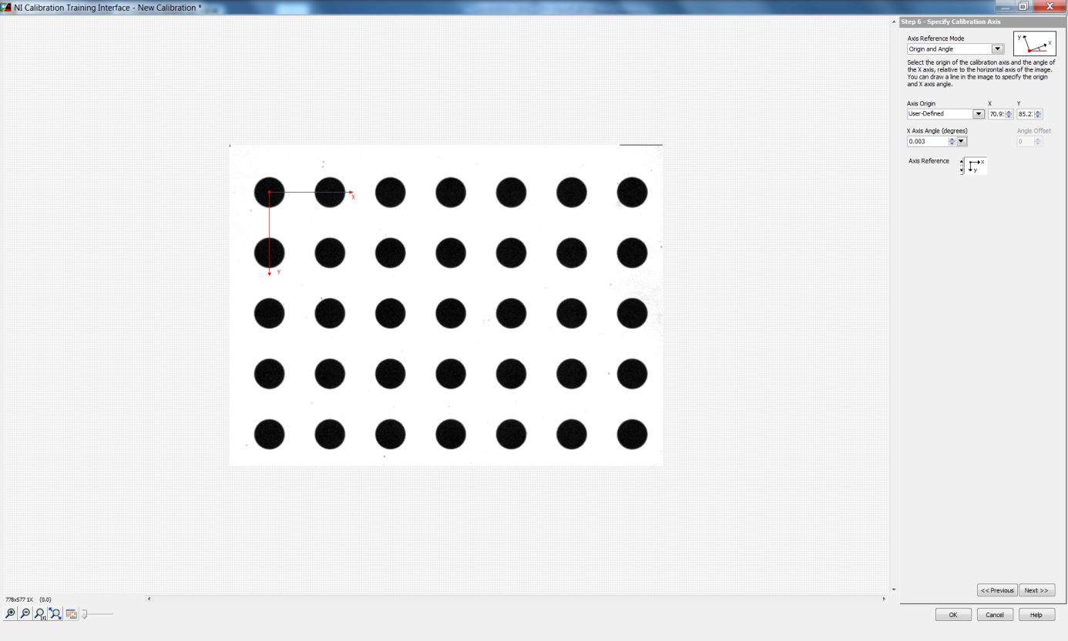

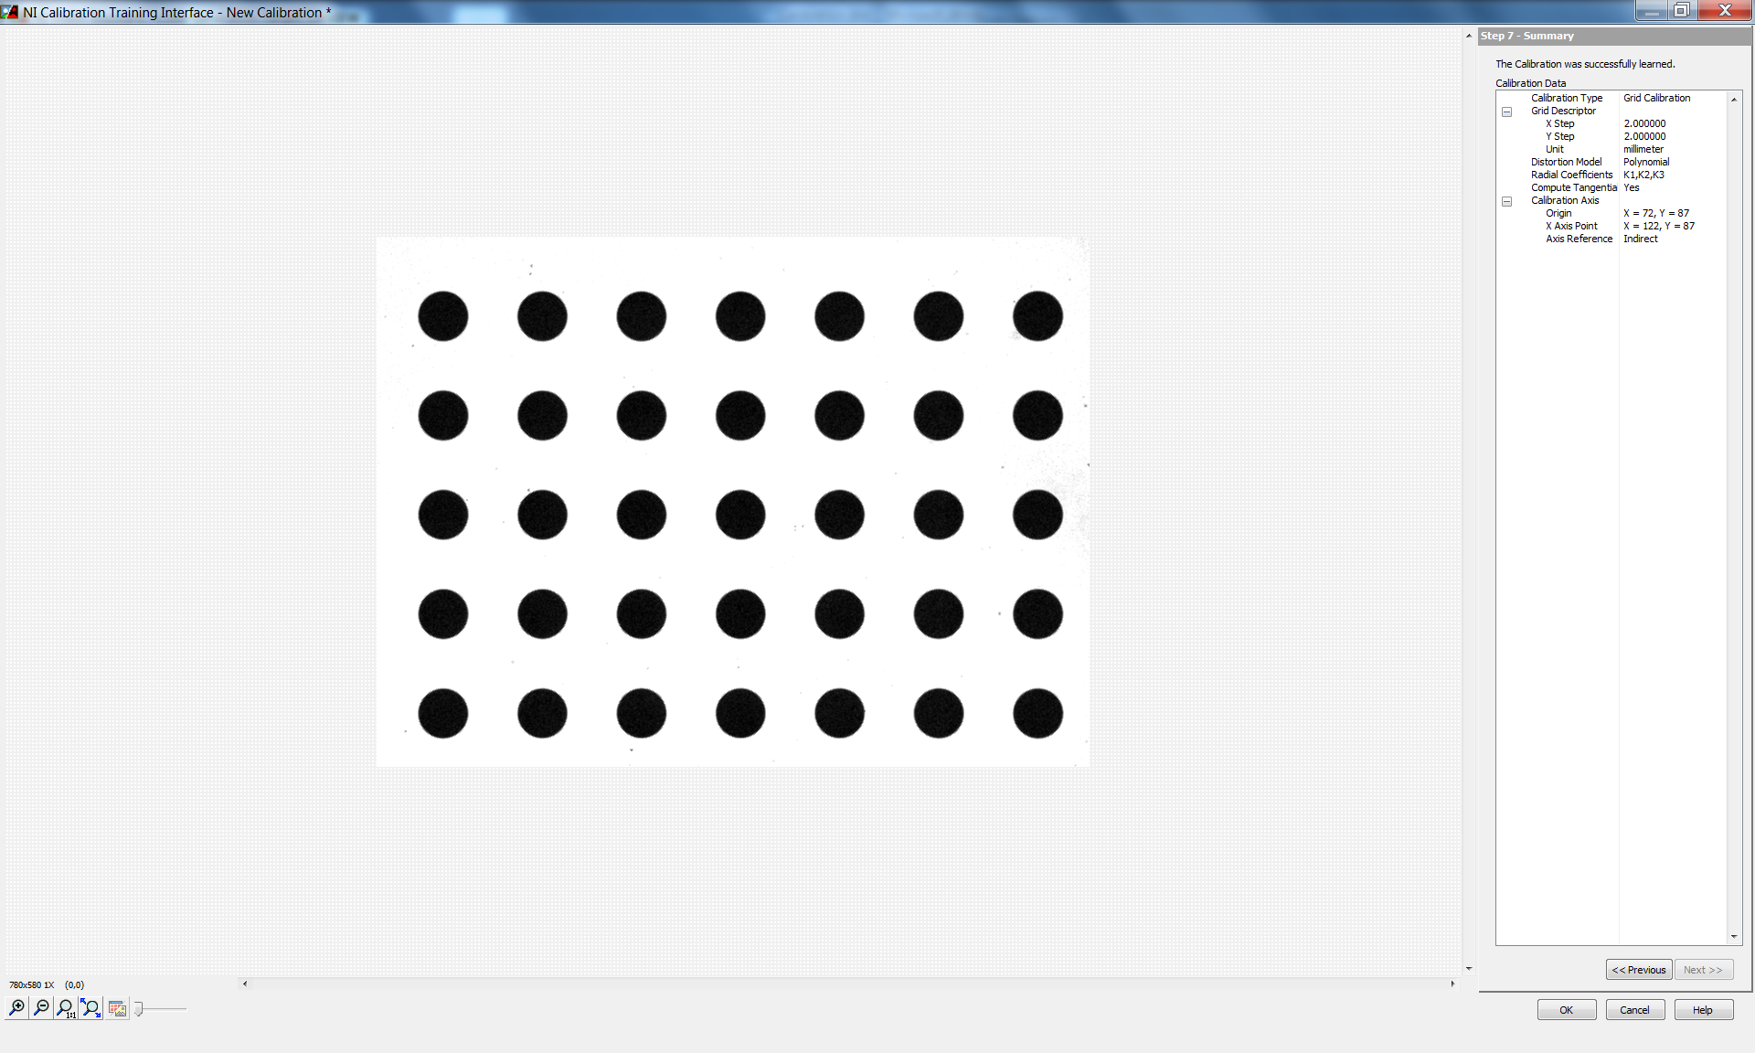

The "Edit Calibration" button is enabled when the saved calibration template is opened again for performing changes (modifications).

**Note:** It is highlighted by a red box as shown in the figure below.

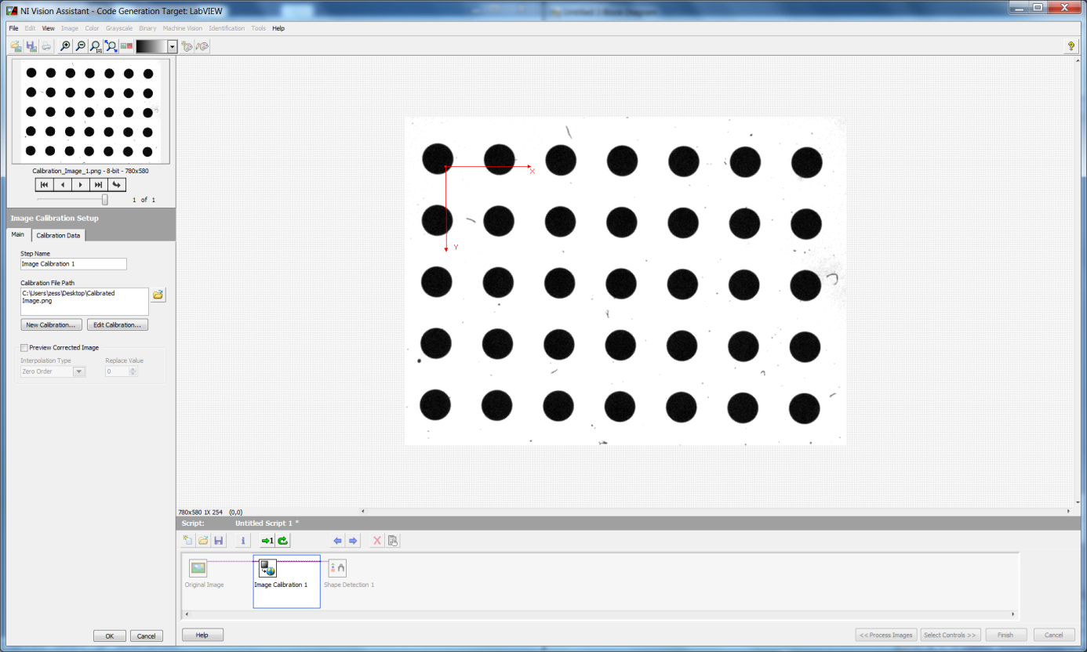

**Process** **:**  Calibration of the camera lens distortion

# Test Target Grid : Edmund Optics - Chrome on Glass, 3 Frequency Grid Distortion Target

**Grid Specifications:** Dot Diameter - 1mm ±0.0025mm

Dot Center to Center Spacing - 1mm ±0.0025mm

# LabVIEW Version : LabVIEW 2016 (32 bit)

**Calibration Method:** NI Vision and Motion - Vision Express-Distortion Grid Calibration

**Step by Step Calibration**

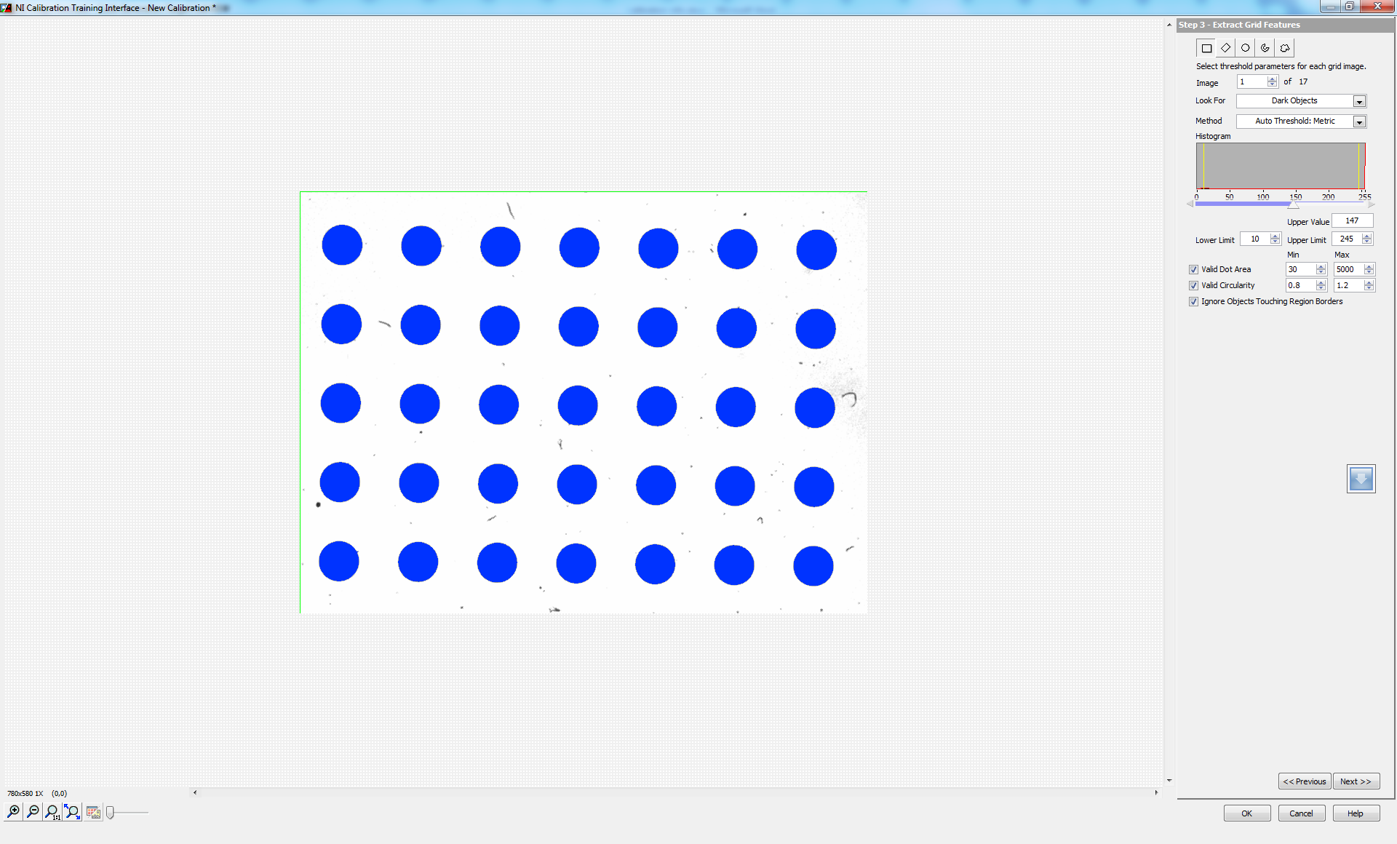

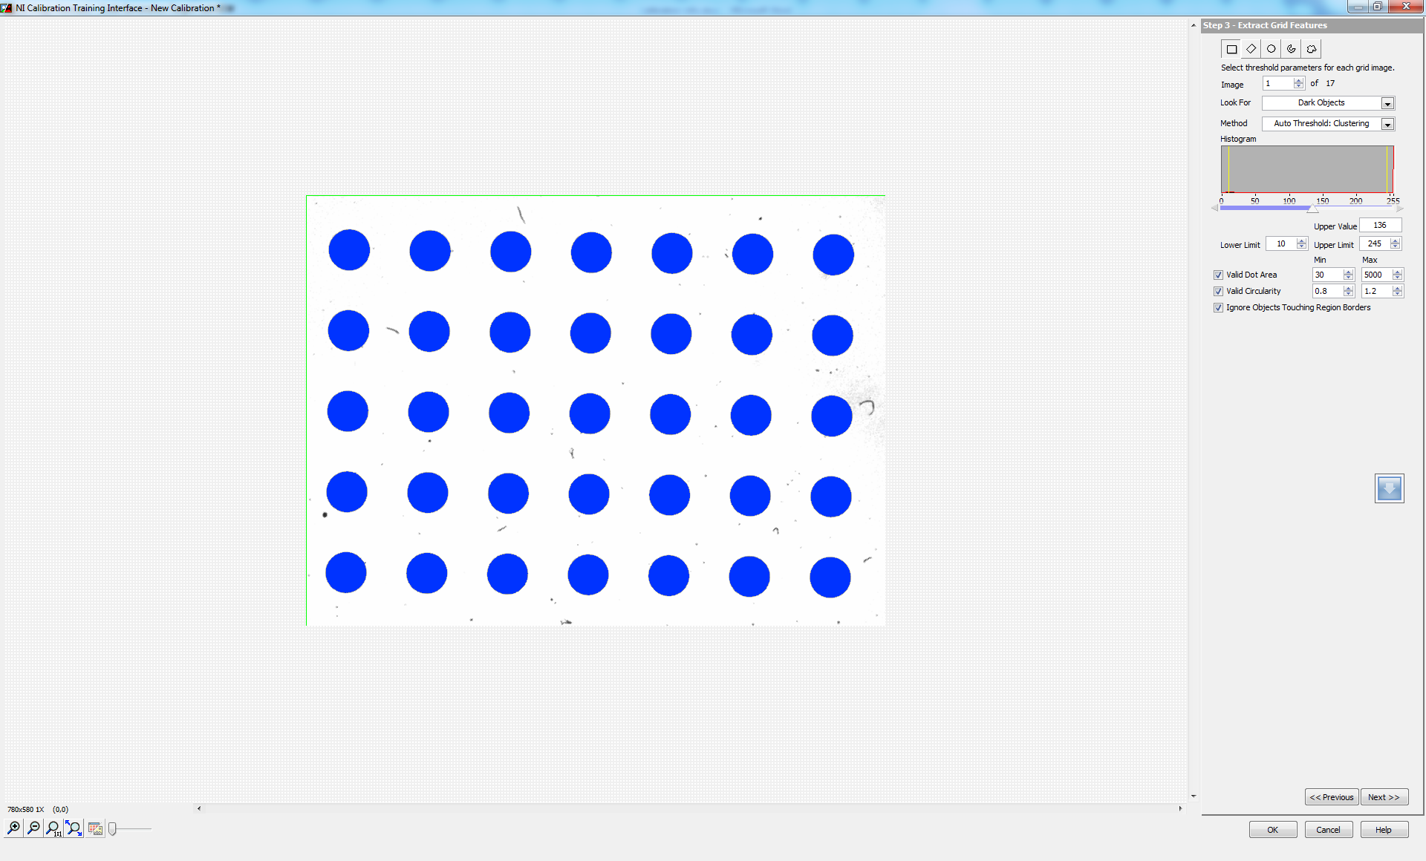

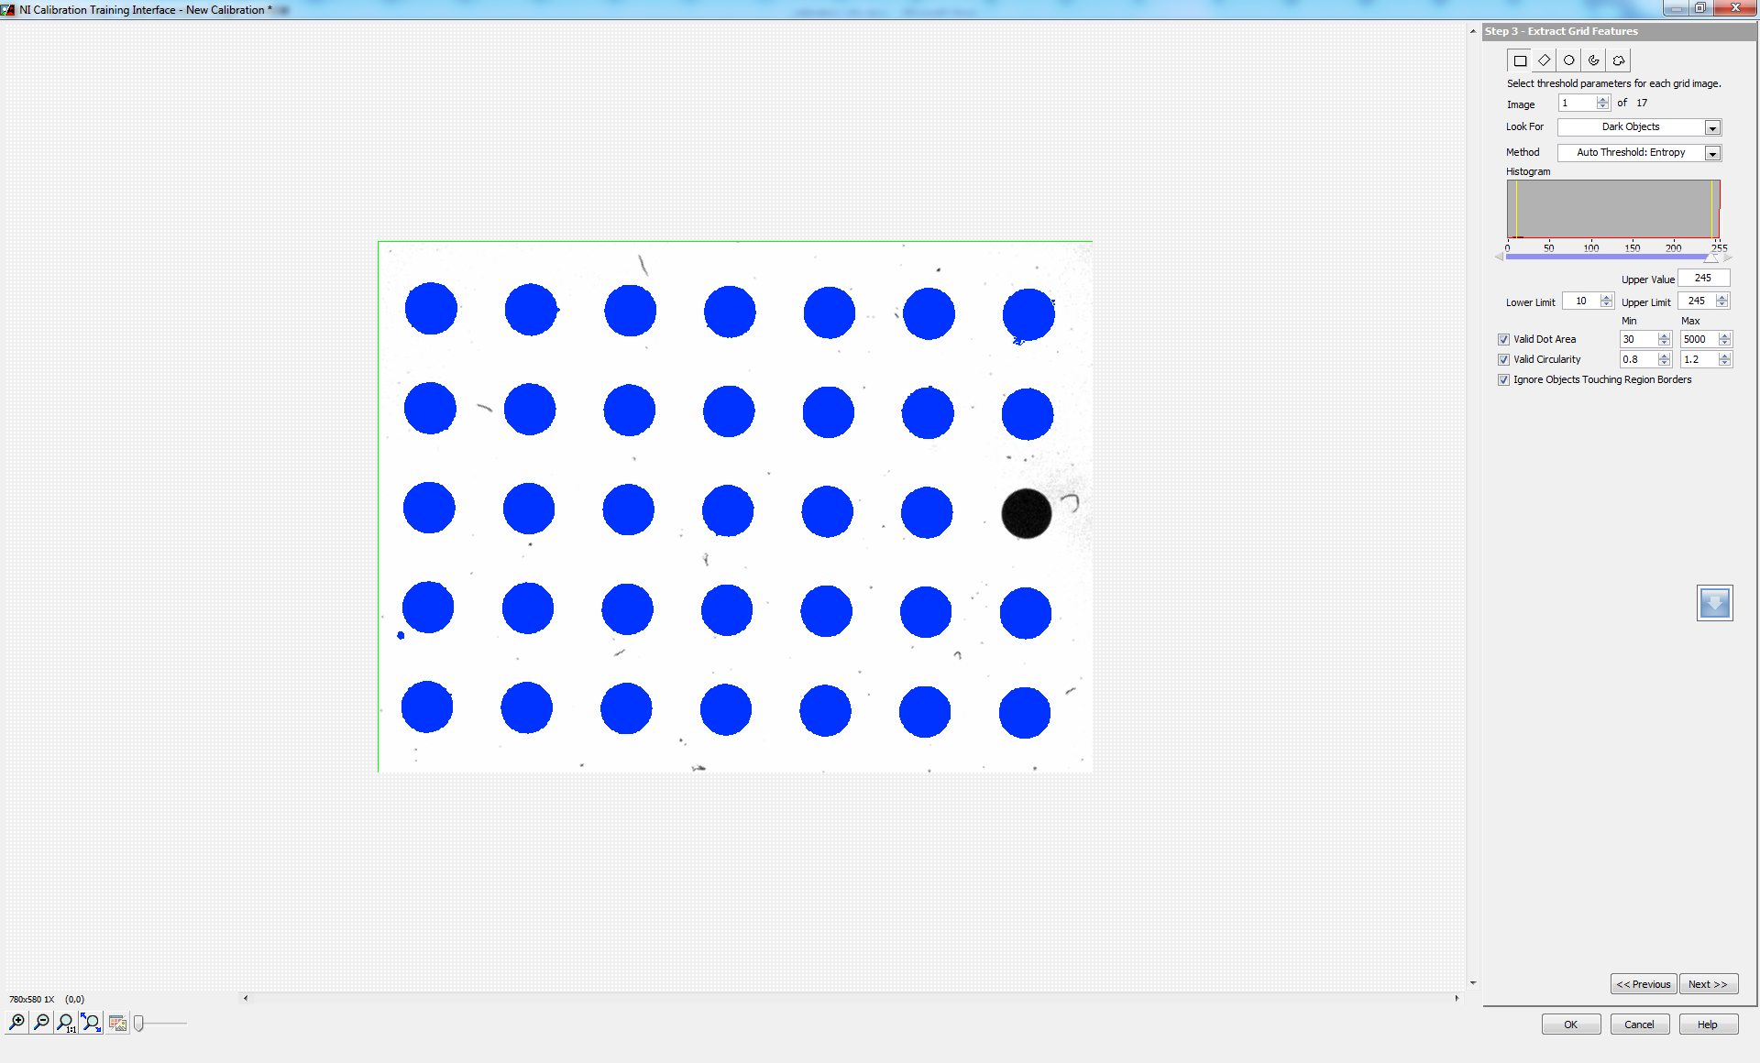

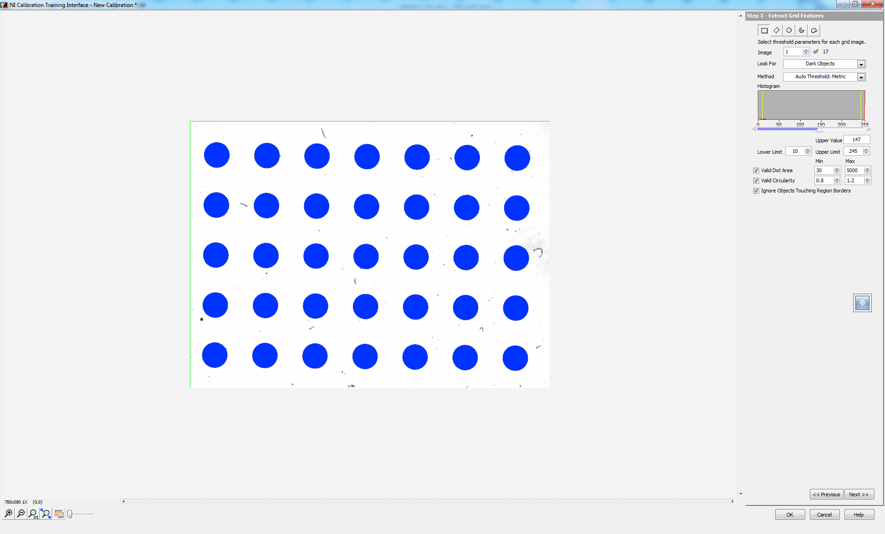

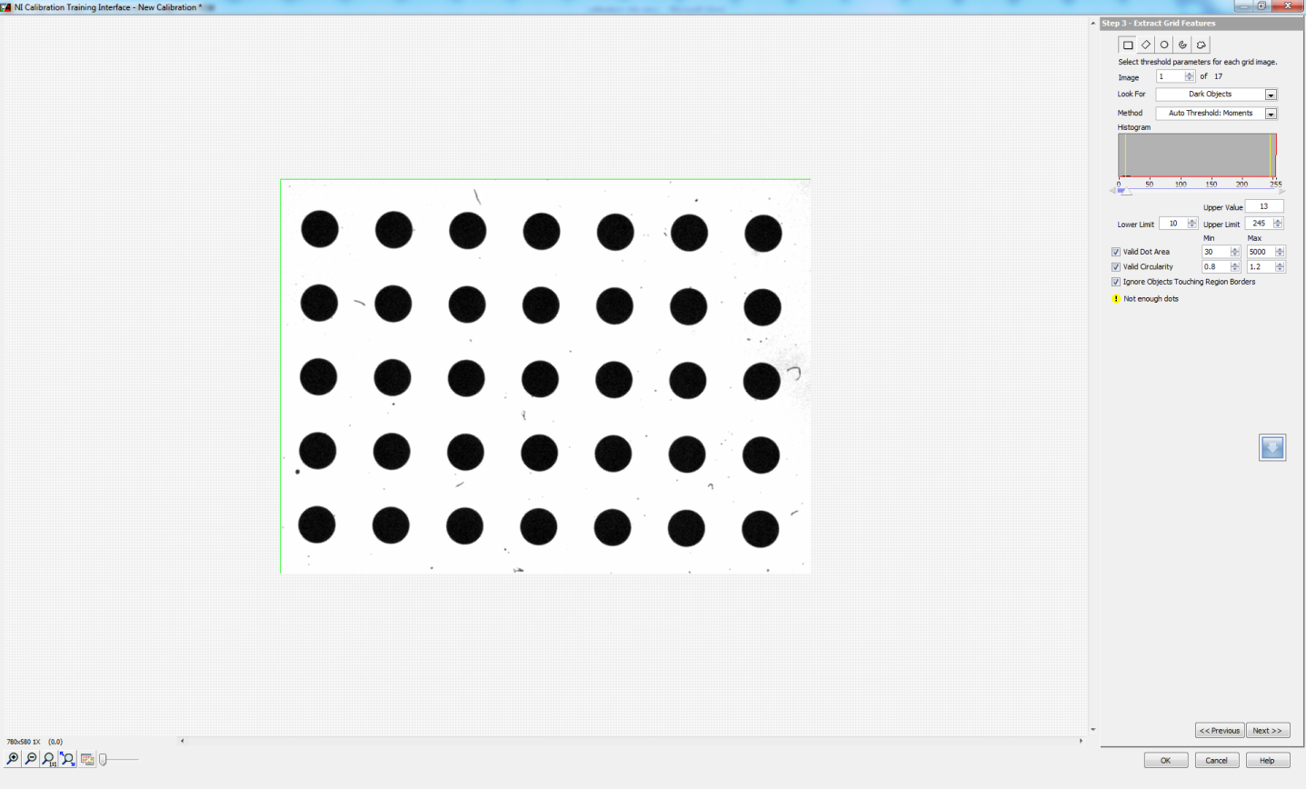

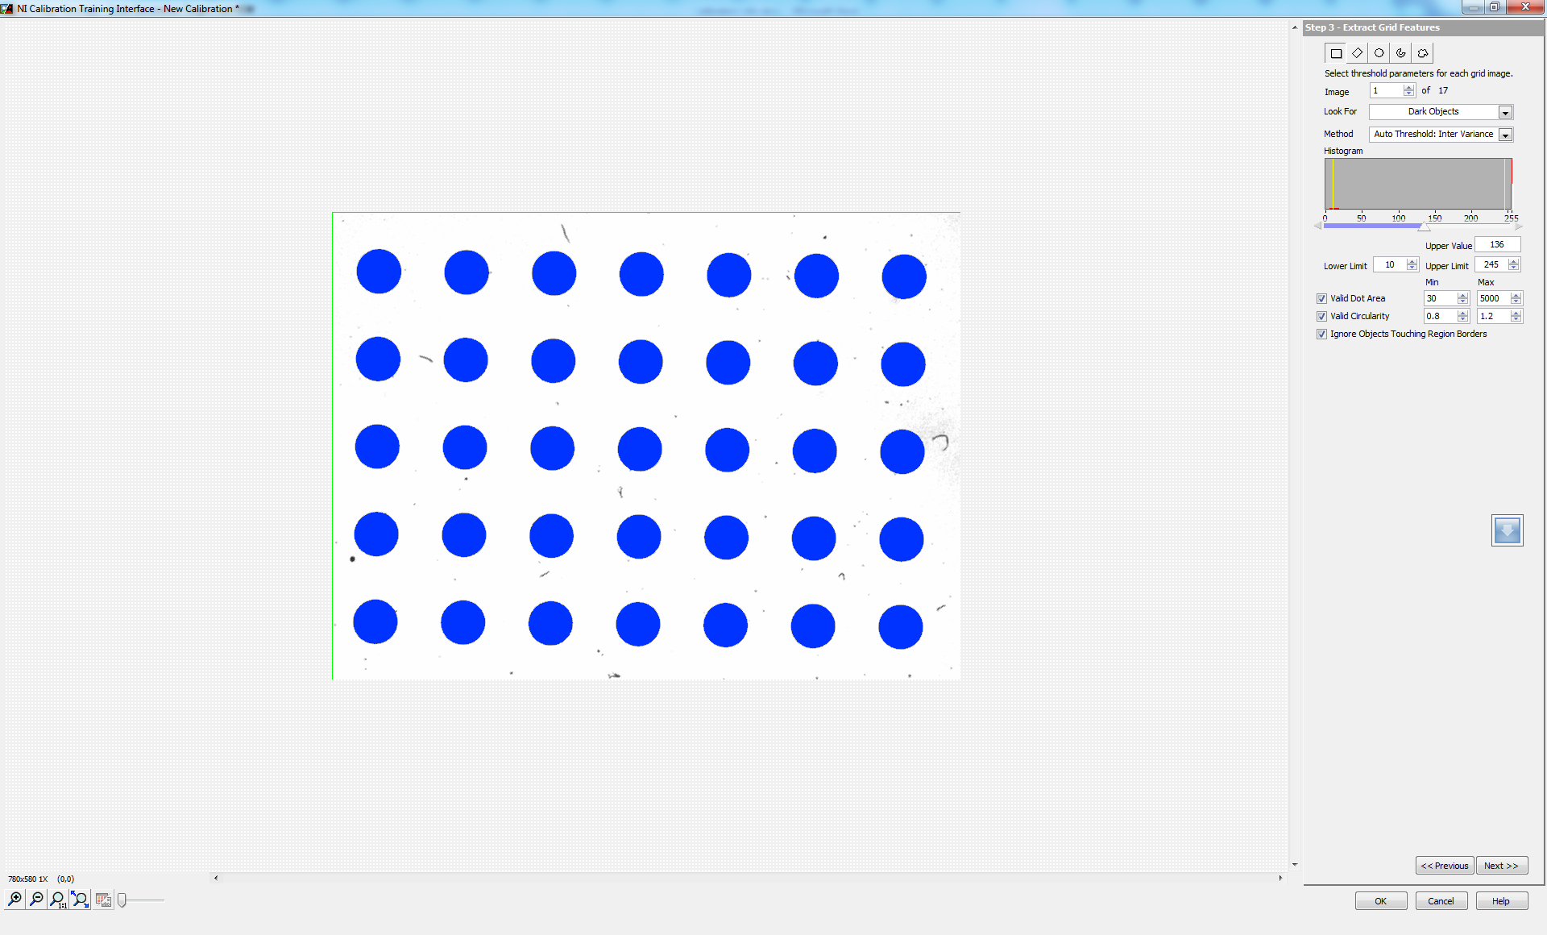

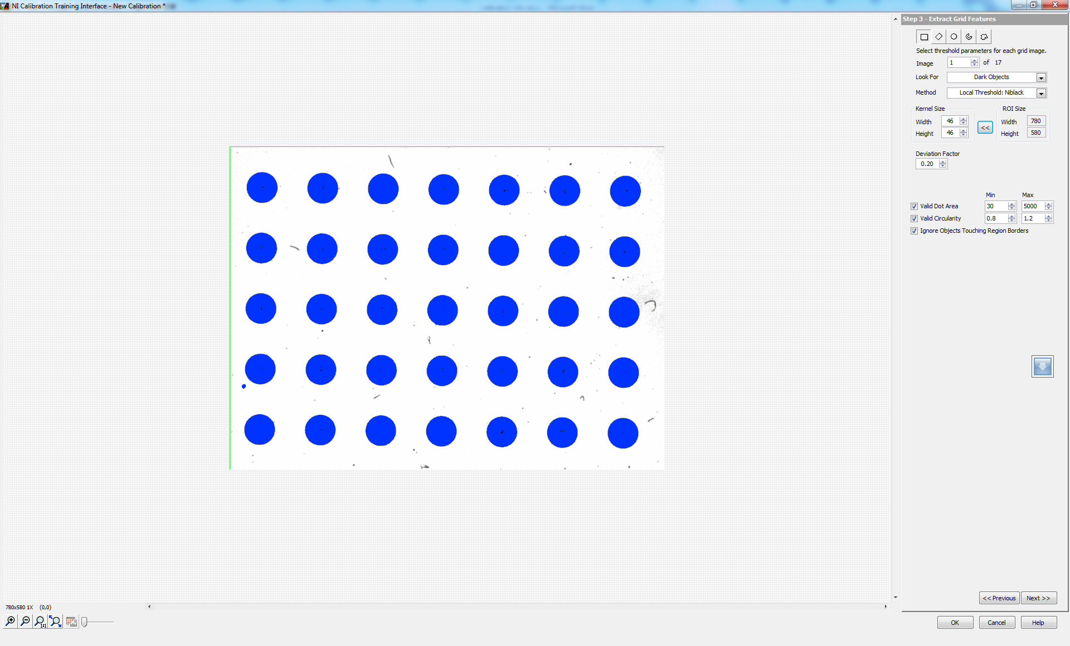

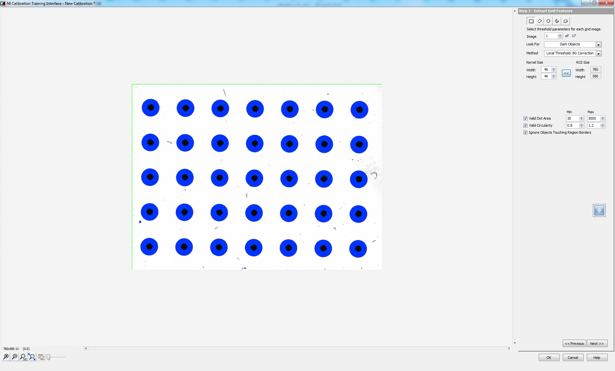

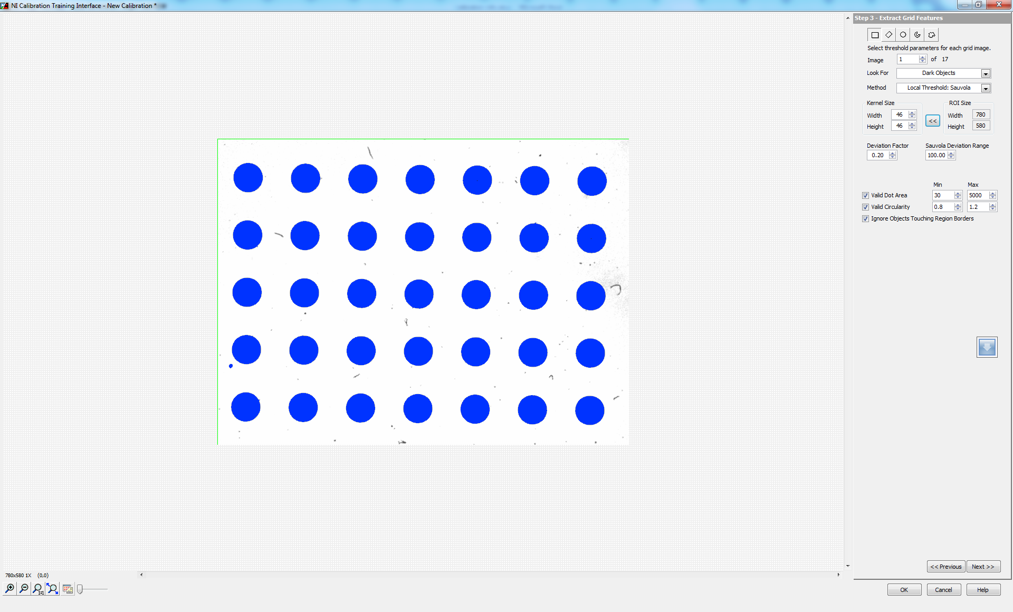

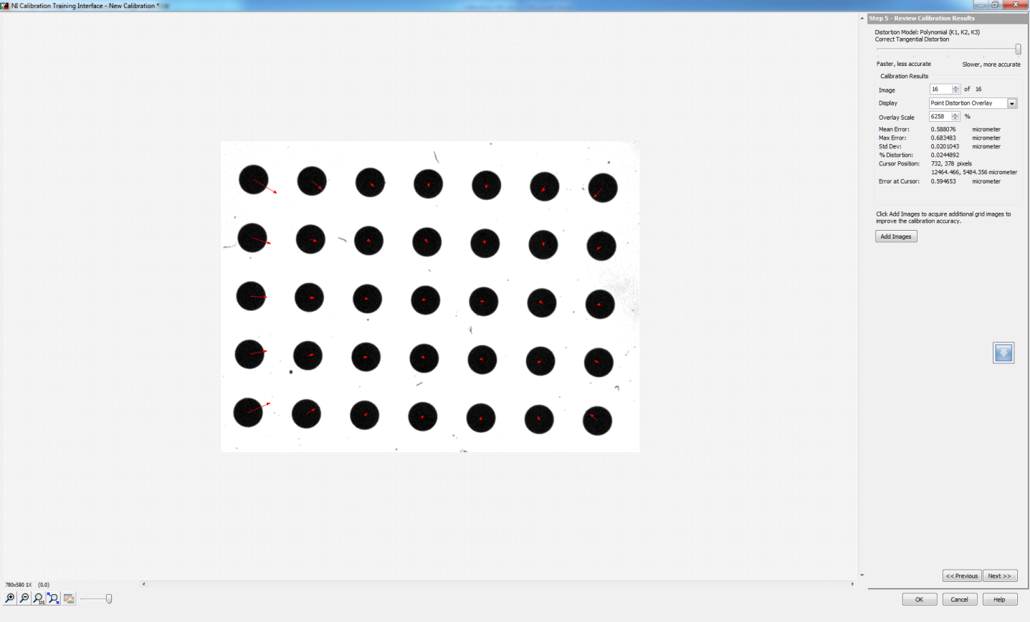

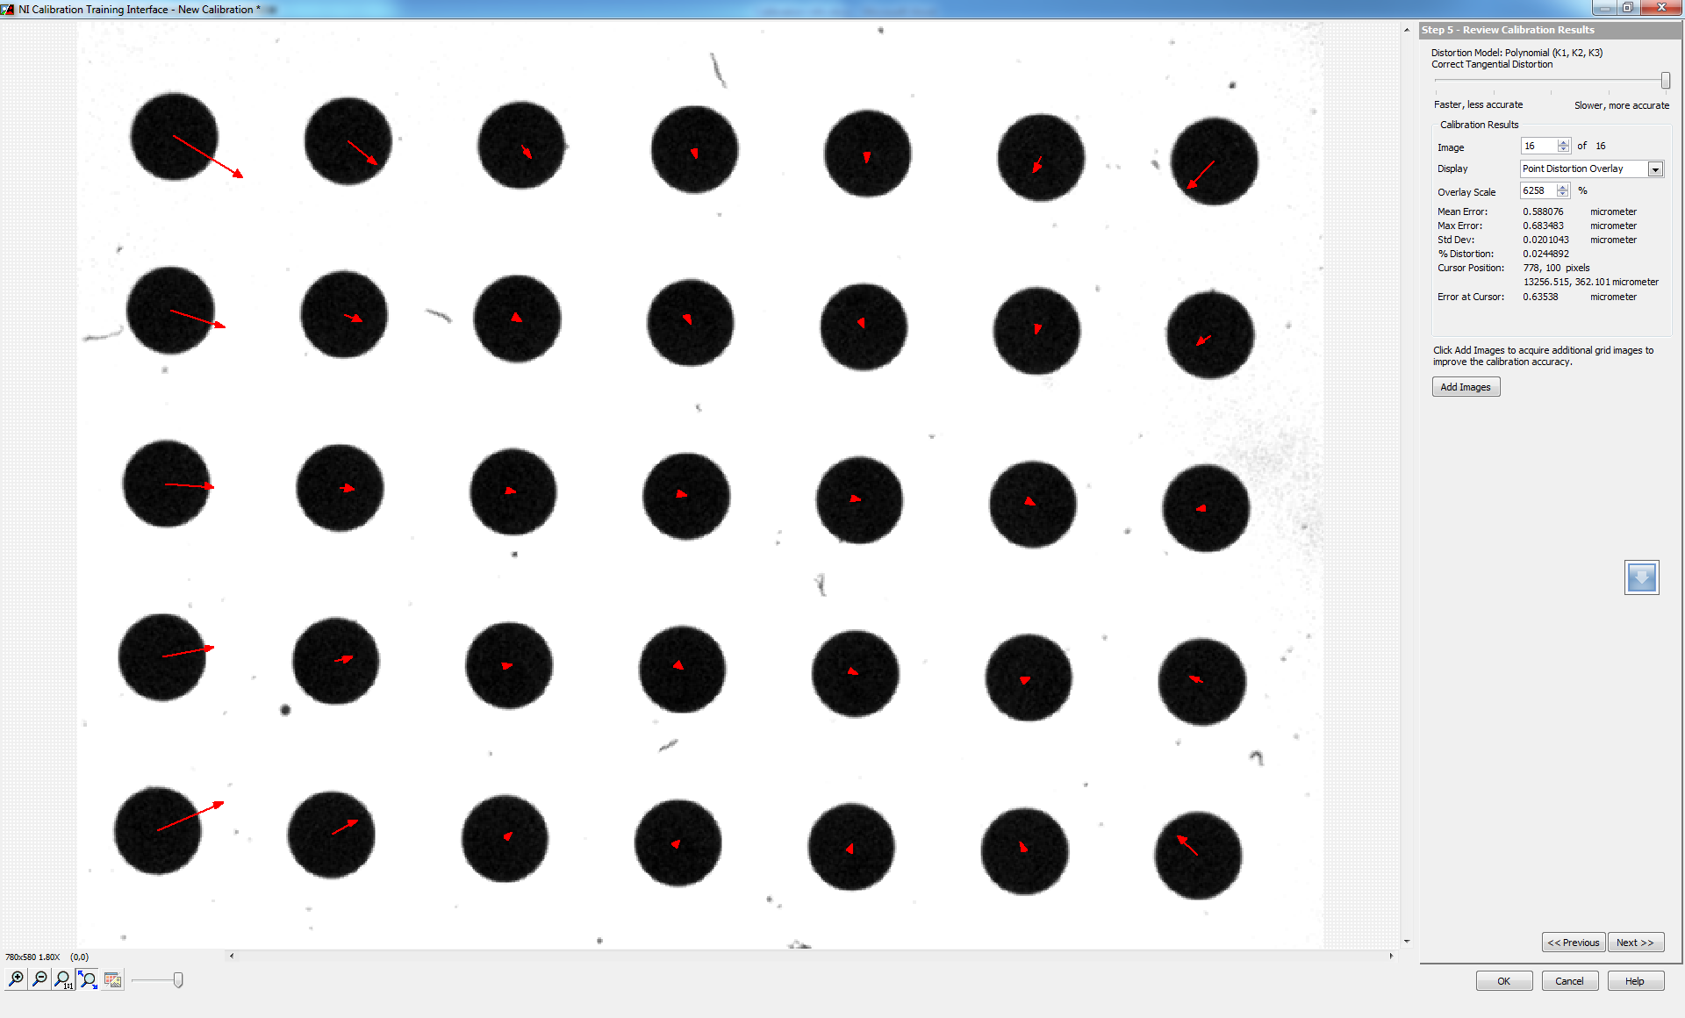

The "Edit Calibration" button is disabled when the saved calibration template is opened again for performing changes (modifications).

**Note:** It is highlighted by a black box as shown in the figure below.

